PROGRAM – 29, 30, 31

HARINI. R

192324108

29. Write a LEX program to print all HTML tags in the input file.

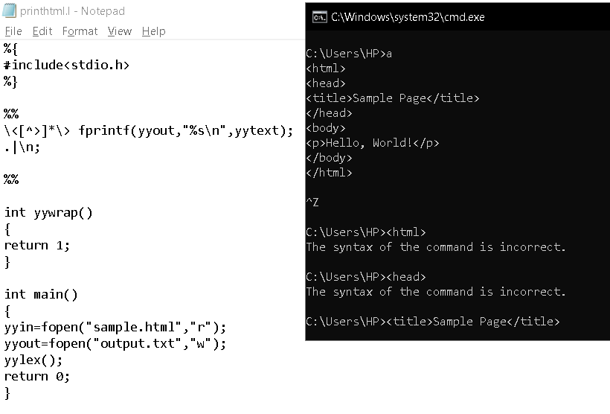

30. Write a LEX program which adds line numbers to the given C program file and display the same in the standard output.

31. Write a LEX program to count the number of comment lines in a given C program and eliminate them and write into another file.

